The University of Sydney
Business School
Early Feedback Task
Week 2 Workshop Report: Planning the Riverside Sounds Community Festival
Student ID: [Enter your SID]
Unit of Study: [Enter Unit Code and Name]
Date: August 2026

Week 2 Workshop Report: Planning the Riverside Sounds Community Festival
In Week 2, the workshop simulated the planning of Riverside Sounds, a two-day outdoor music and food festival approved by the Riverside City Council to bring residents together, support local artists and small businesses, and provide an accessible community event. Working in a learning community, the group completed three interrelated project management activities: developing a work breakdown structure (WBS), sequencing the activities into a network diagram, and performing a critical path analysis. This report summarises the results of the three workshop activities.
Task 1 required a WBS based on fifteen major activities (Table 1), using a clear hierarchical numbering system (Project Management Institute, 2021). Each of the fifteen parent activities was decomposed into at least two level-2 sub-activities, and further broken into fifty-three level-3 work packages in total. For example, activity 5, “Festival program and artist booking” (25 days), was divided into program curation; artist shortlisting; and negotiation and contract finalisation. The WBS clarified deliverables and provided the foundation for sequencing in Task 2.
In Task 2, the fifteen activities were sequenced into a network diagram that reflected logical dependencies and constraints, for example venue selection preceding site layout, and permits and insurance depending on site design (Figure 2). Following the prescribed template, each node recorded the early start (ES), early finish (EF), late start (LS), late finish (LF), float, activity identification number, description and duration (Figure 1). Forward and backward passes were then applied to compute these values for every activity.
Task 3 applied critical path analysis to the network. The critical path was identified as activities 1–2–5–7–8–12–13–14, with an estimated project duration of approximately 149 days (Figure 2). Because critical activities carry zero float, any delay to them would delay the festival; therefore the group recommended close monitoring of artist booking and compliance approvals, which carry the greatest duration uncertainty. The analysis demonstrates how scheduling techniques support realistic completion dates and effective resource priority (Kerzner, 2017).
In summary, the workshop illustrated the logical progression from project decomposition, to scheduling, to critical path analysis. These techniques enable managers to identify priorities, allocate resources and control project timelines, and will be applied to the full festival project throughout the semester.
Table 1: Major activities of the Riverside Sounds project (WBS level 1)
ID | Activity | Duration (days)
1 | Project initiation and feasibility study | 8
2 | Event concept, scope and project charter | 10
3 | Venue selection and booking | 12
4 | Stakeholder consultation and engagement | 15
5 | Festival program and artist booking | 25
6 | Site layout and technical design | 18
7 | Sponsorship and funding arrangements | 20
8 | Permits, insurance and compliance approvals | 25
9 | Supplier procurement and contract award | 30
10 | Marketing, communications and ticketing setup | 24
11 | Staffing and volunteer planning | 18
12 | Operations, security, safety and contingency planning | 22
13 | Site setup, equipment installation and rehearsals | 5
14 | Festival delivery | 2
15 | Pack-down, evaluation and project closure | 7

Source: Workshop slides, Learning Community 2, Week 2.
Figure 1: Node template used for the network diagram
ES | ID | EF
Float | Description
LS | Duration | LF

Figure 2: Network diagram and critical path (thick arrows) of the Riverside Sounds project
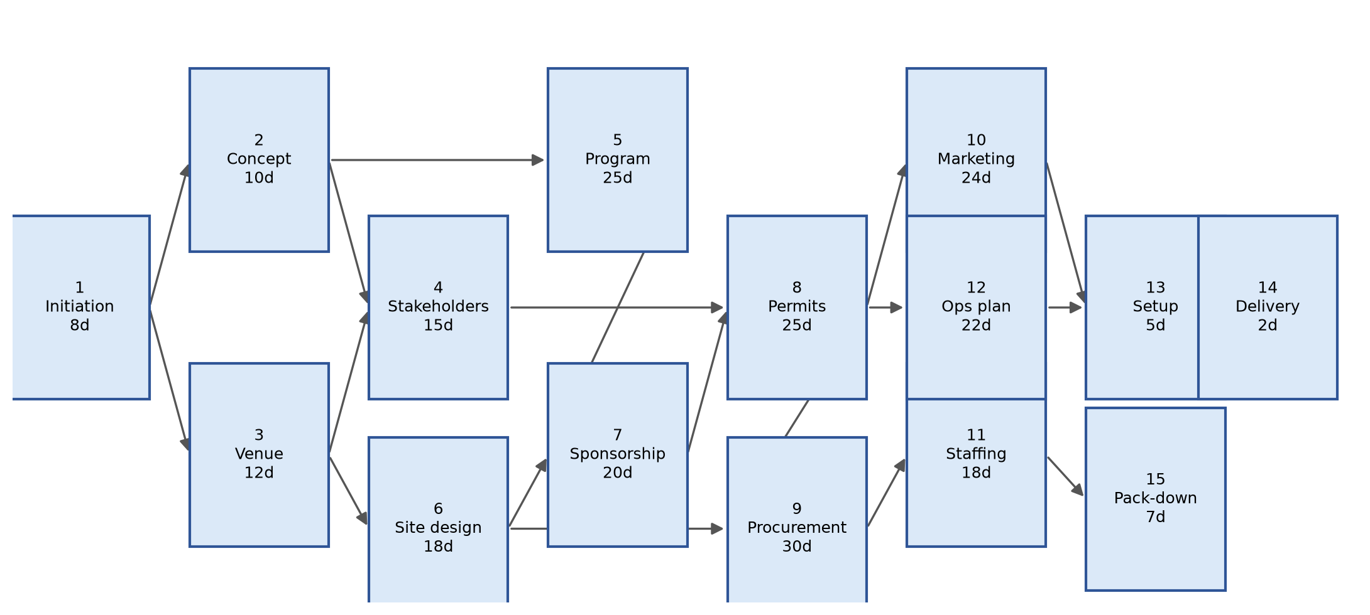

Reference List
Kerzner, H. (2017) Project Management: A Systems Approach to Planning, Scheduling, and Controlling. 12th edn. Hoboken, NJ: John Wiley & Sons.
Project Management Institute (2021) A Guide to the Project Management Body of Knowledge (PMBOK Guide). 7th edn. Newtown Square, PA: Project Management Institute.

